Assignment 5

*Random Seed:* 23

**Minimum Test**:

2-3

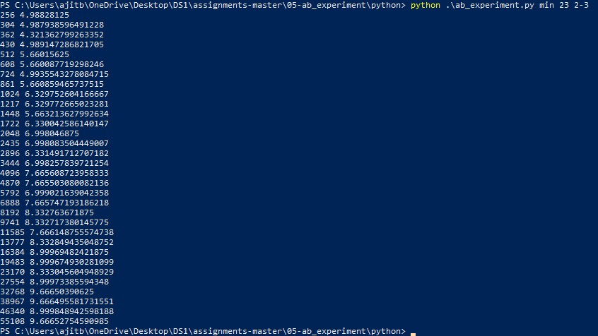

2-4

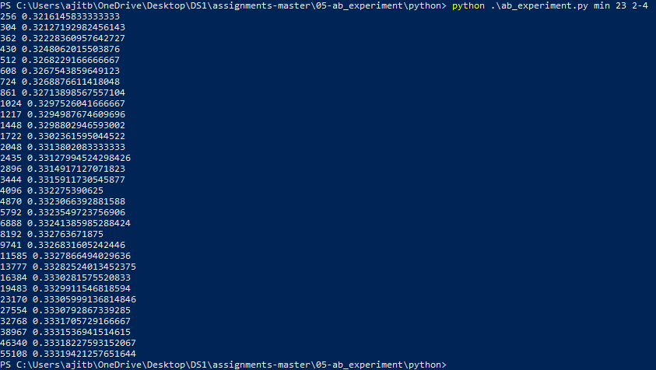

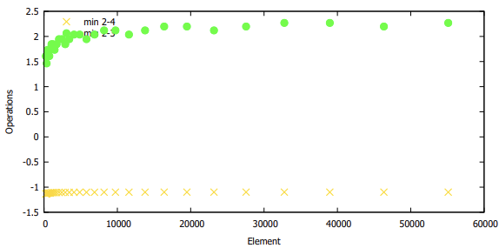

From the comparison between 2-3 and 2-4 trees in case of minimum test, the graph obtained which the curve of 2-3 tree is above the result of 2-4 tree. The graph of 2-4 tree produced similar to a linear graph, while 2-3 tree produced slight sudden increase at the start and gradually kept increasing. From the graph, we can clearly state that the graphs has no overlap between the min test of 2-3 and 2-4 trees.

**Insert test**:

2_3

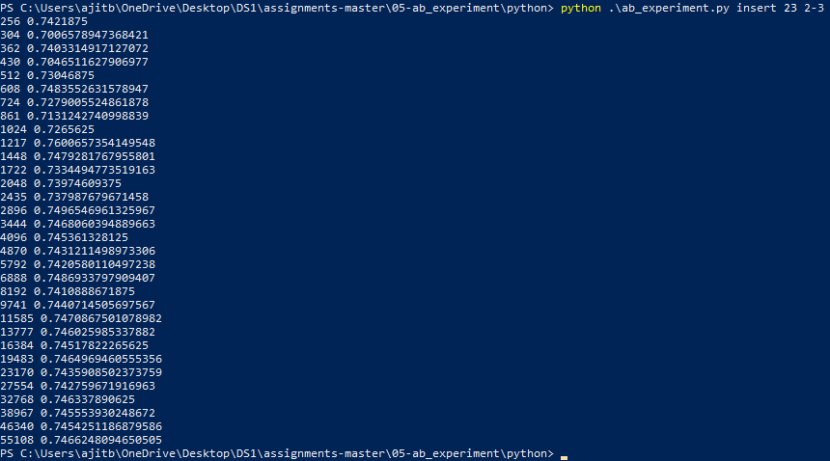

2_4

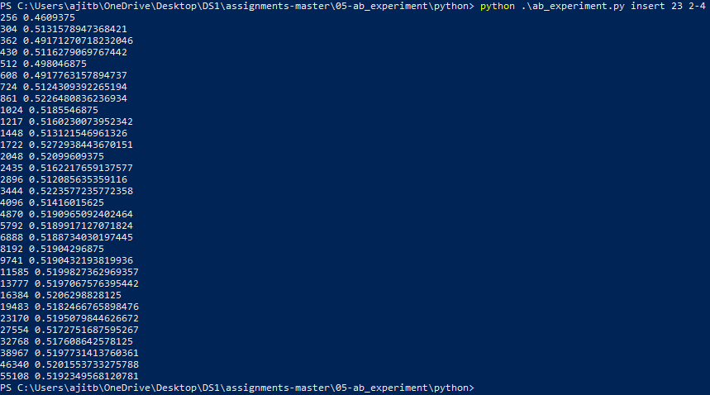

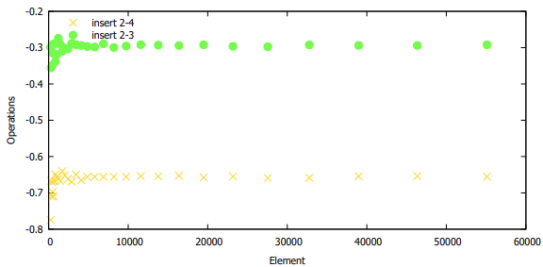

Similar to min test, insert test as well resulted with the curve of 2-3 tree is above the result of 2-4 tree. The graph of 2-4 tree produced a curve with sudden raise in plots with many plots at a period and gradually resulted with a straight line, while 2-3 tree produced slight sudden increase at the start with many plots at a period and gradually resulted with a straight line similar to 2-4 tree. From the graph, we can clearly state that the graphs has no overlap between the min test of 2-3 and 2-4 trees.

Let us calculate time complexity of Insert. In the worst case, we visit Θ(1) nodes on each level and we spend Θ(b) time on each node. This makes Θ(b ·log n/ log a) time total. It remains to show that nodes created by splitting are not undersized, meaning they have at least a children. We split a node v when it reached b + 1 children, so it had b keys. We send one key to the parent, so the new nodes v1 and v2 will take b(b − 1)/2c and d(b − 1)/2e keys. If any of them were undersized, we would have (b − 1)/2 < a − 1 and thus b < 2a−1.

**Random test**:

2-3

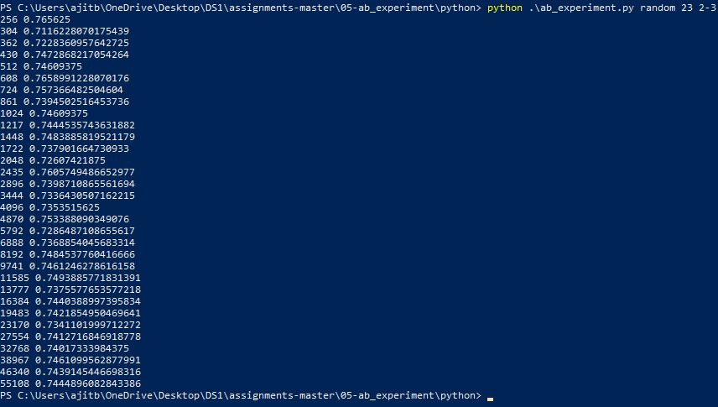

2-4

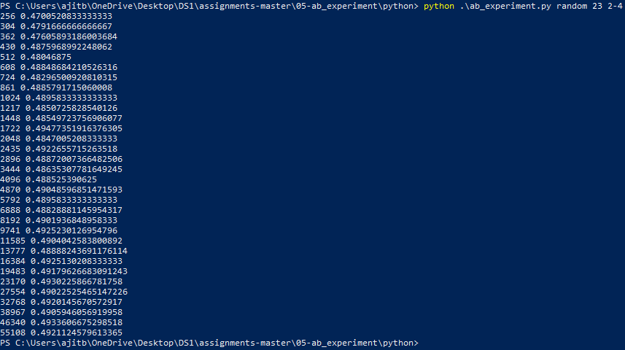

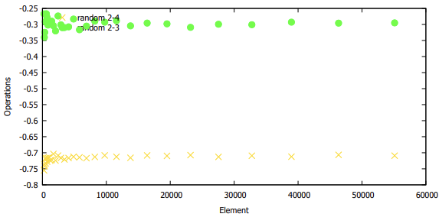

Similar to min test & insert test, random test as well resulted with the curve of 2-3 tree is above the result of 2-4 tree. In case of both 2-3 & 2-4 trees, at the start, there was random ‘n’ plots resulted and gradually the graph resulted in ups and downs curves. The similarity of the graph can be found in it’s nature stated before. But there is no overlap on the plots, similar to min and insert tests cited before.



In all the plots above, in case of 2-3 tress is represented in green circle and 2-4 tree is represented in gold x mark.